
Eclipse Identity Recognition CorporationTM provides Personal Identity Recognition via its face-based analytics known as INDIfaceTM. It is used to detect faces and facial features and then generate face templates for searching and matching. In addition, the INDIface analytics can also determine skin tone, upper and lower clothes color, and an estimated height of a person. The INDIbaseTM system provides for the enrollment, storage, management, retrieval, and matching of INDIface templates. INDIbase also manages facial and other images as well as personal identification and characteristic data.
FusionIRTM, the INDIface Software Development Kit (SDK), allows third-party developers to create custom applications using EclipseIR's technology. It runs on Microsoft Windows-based systems as a stand-alone console application with a capacity of over 50,000 enrollments.
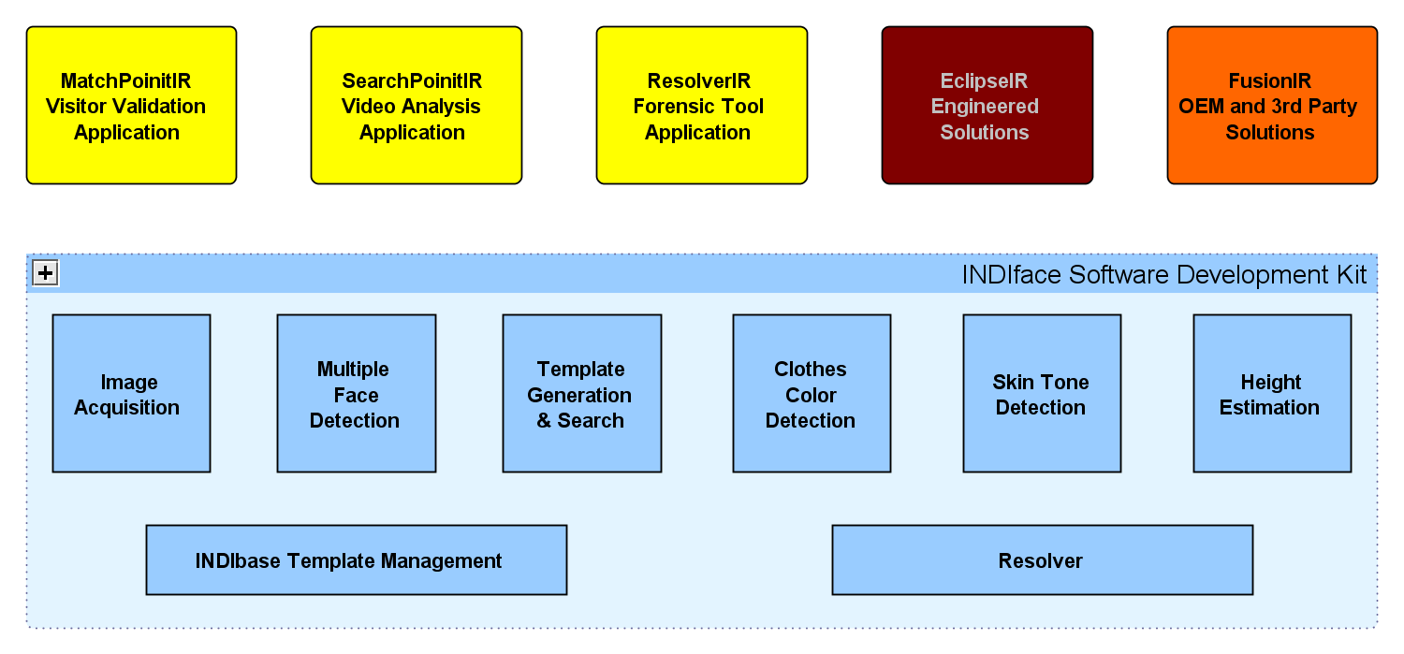

C3: Command, Configuration, Control
The behavior of the INDIface SDK is currently controlled via the Windows registry. Currently there are over 150 configurable values. Most of the configuration values are "volatile," that is they can be changed in the registry at any time and the executing console will automatically pick up the changes. Different registry base keys can be specified for different applications or uses.

Input
The INDIface SDK accepts single still images or sequences of frames, such as Motion JPEG. Image formats supported include BMP, PNG, and JPG. The image source can be a live IP camera or a “hot directory.”
Live IP input expects an HTTP-scheme URL that will return a single frame. The SDK has been used with Axis 210-series cameras (and 240-series NTSC video encoders) and Arecont IP cameras. It should be compatible with ONVIF compliant cameras.
Stored images (whether individual stills or sequences) are processed from a “hot directory.” Hot directories have several advantages: When all images have been processed, you can start processing again-mostly useful for testing or demonstrating. Images can be deleted from the directory after they have been processed. Image files can be moved to a separate directory after they have been processed. Processing can be started on an empty directory and image files are processed as they are dropped in to the "hot" directory.

Processing Steps

Image Pre-processing & Detection
Once a single frame has been collected from an IP camera or hot directory, it is preprocessed and a frontal face detector is used to scan for potential faces in the image. Each of the potential faces is extracted from the original frame, optionally scaled and filtered, and a face feature detector is applied.
Unlike other facial detection and recognition systems that require near-perfect, carefully-staged facial images (think passport photos), INDIface will work with images that result from typical surveillance applications. INDIface can easily tolerate 30° of roll and nearly 90° with adjustment of parameters. In addition, it can continue to provide useful results beyond 35° of combined pitch and yaw.

Template Generation & Informal Matching
From the detected location of facial features the face image is “normalized” by aligning the eyes to fixed points. From the normalized image, an INDIface template generation will be performed. This template can be enabled for informal matching where a one-to-many search is executed against any active INDIbase enrollments.
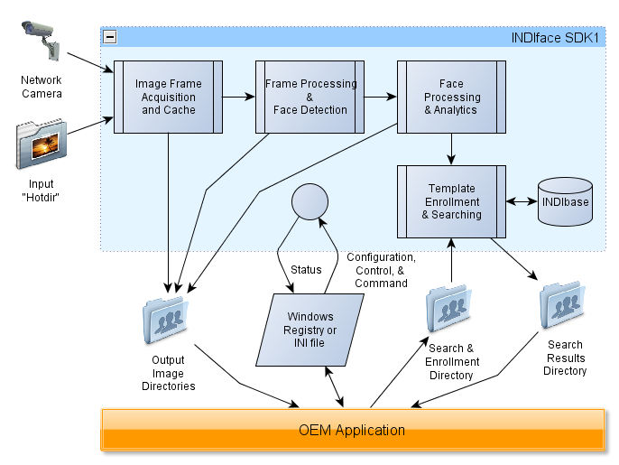

Analytics & Resolver
If the template generation process confirms a likely human face, then other analytic data can be collected. The face position and size can be applied to calibration data for fixed camera positions to interpolate an estimated height of the person. The location of the upper and lower body can be determined and the characteristic color of those areas can be collected and compared against specified target colors. Representative areas of the face can be sampled to collect an average skin tone for comparison against multiple specified target colors.
The quality of the detected potential face, the consistency of the generated template, and the confidences of informal face match, upper and lower clothes color matches, height estimation, and skin tone match can then be fed to the resolver. The (positive or negative) weighted average of each of these factors can be combined to a resolved confidence value.

Output
Output data consists of frame images, cropped face images, normalized face images, and XML data files. The following table describes the various output categories. Additional “diagnostic” image directories to understand the detection and generation process.
Name | Data | Markings | Description
Capture | Frame | none | Raw capture image
Input | Frame | none | Preprocessed Input Image
Marked | Frame | head, eye, body | Marked input
Unmarked | Frame | none | A frame that would be marked, but unmarked
NoMarked | Frame | none | A frame that did not earn marks
NoFace | Frame | none | No potential faces detected
NoEyes | Crop | none | Potential face detected, but no eyes
BadFace | Norm | none | Eyes detected, but low consistency template
Face | Norm | none | Face and features detected (and matched if enabled)
MarkedFace | Norm | eye | Face with eyes marked
FaceCache | Norm | none | Ditto; number of files managed by console
Height | Frame | head | Height estimation matched
NoHeight | Frame | head | Height estimation not matched
HeightFace | Norm | none | Face where height estimation matched
Clothes | Frame | head | Upper and/or lower clothes color match
NoClothes | Frame | head | Clothes color did not match
ClothesFace | Norm | none | Face where clothes matched
SkinColor | Frame | head | Matched one of the skin colors
NoFaceColor | Norm | none | Face where none of the skin colors matched
Resolved | Frame | head | Resolved (original frame marked)
ResolvedFace | Norm | none | Resolved (face only)
XML | XML | n/a | XML data of frame, faces, and analytics
Match | Norm | none | Matching faces from INDIbase enrollments
NoMatch | Norm | none | Faces not meeting casual match (if enabled)
Body | Crop | none | Body below detected face
Frame images and XML data files are identified by an Image ID. For frames captured from IP cameras, the image ID consists of a date stamp to the thousands of the second optionally prepended with a specified Camera ID. For images read from a directory, the image ID is the base file name. Cropped and normalized face image files are identified by a Face ID. The face ID consists of the image ID appended with the x,y coordinates of the position of the face in the original image and the quality and consistency values for the detected face. The output files are distributed to a set of directories specified in the configuration.

INDIbase Commands
The SDK console has three command modes to allow applications to interact with the active INDIbase enrollment.

Enroll
In Enroll mode, an application can use the commands to:
- Enroll new unidentified (not associated with a person) faces to the INDIbase.
- Create a new person and enroll faces for that person.
- Add more faces to an existing person's enrollment.
- Delete an unidentified face from enrollment.
- Delete a specific face from a specified person's enrollment.
- Remove a specified person and all enrolled faces for that person from the INDIbase.
- Remove all people and faces from the database.

Retrieve
In Retrieve mode an application can retrieve single enrollment images (from a specified person or unidentified) or all faces enrolled for a person. Also, reports and statistics from the INDIbase are available.

Search
In Search mode, and application can submit faces to be searched against the current INDIbase enrollment.
- With the Verify command, the submitted faces are compared to a specified person and a single confidence level is returned.
- With the VerifyList command (to be implemented soon), submitted faces are compared to a specified list of a few persons. The results are the list of persons sorted by their confidence.
- With the Search command the submitted faces are compared to the entire INDIbase enrollment. The results are a list of the best matching faces sorted by confidence. In Person Search Mode, results for the same enrolled person are grouped together.
- A new Authenticate mode is being implemented to provide identity verification while gathering additional images of the subject as needed.

